Working with Different Types of Data:
As Spark is still evolving, you can find the latest DataFrame (Dataset) Methods from below page,
http://spark.apache.org/docs/latest/api/scala/index.html#org.apache.spark.sql.Dataset

Submodules like DataFrameStatFunctions and DataFrameNaFunctions have more methods that solve specific sets of problems.
DataFrameStatFunctions(org.apache.spark.sql.DataFrameStatFunctions) -- Holds a variety of statistically related functions
DataFrameNaFunctions(org.apache.spark.sql.DataFrameNaFunctions) -- Holds functions that deals with null data
SQL Functions(org.apache.spark.sql.functions) -- Contains a variety of functions for a range of different data types.

Create a dataframe with retail data,
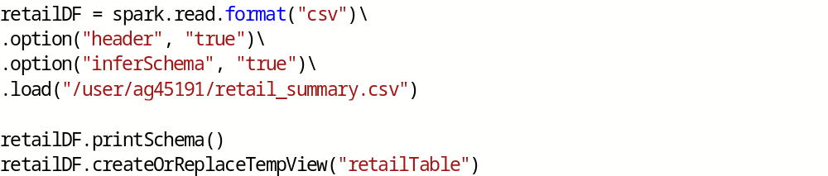

Working with Booleans:
from pyspark.sql.functions import col
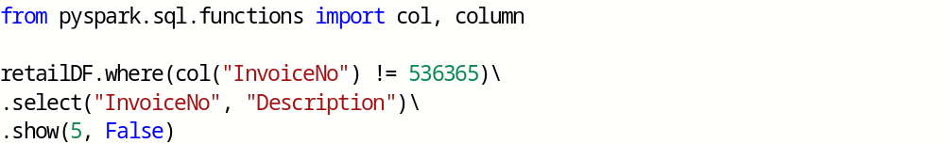

Another option is to specify the predicate as an expression in a string.

Another example,
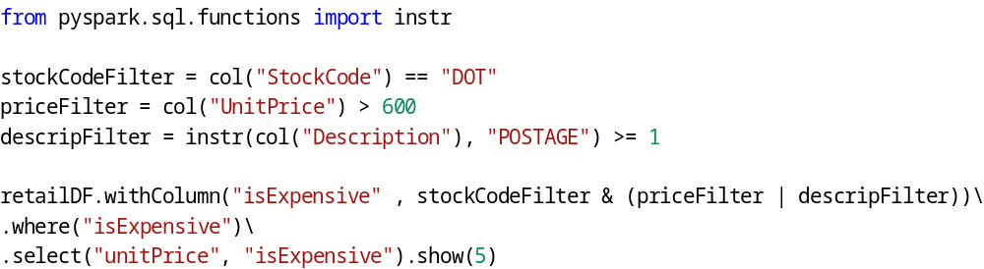

It is easier to just express filters as SQL statements than using the programmatic DataFrame interface like below,
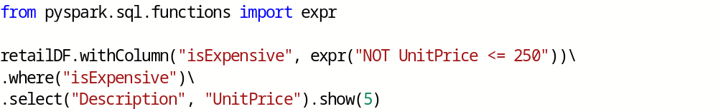

Working with Numbers:
We will be able to multiply our columns together if they are both numerical.
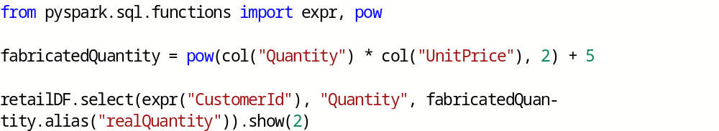

We can do all of this as a SQL expression, as well:

Using round() function,

Another common task is to compute summary statistics for a column or set of columns.

we can also add a unique ID to each row by using the function monotonically_increasing_id().

Working with Strings:
Converting string case:
initcap():
Capitalizes every word in a given string.
Example:
upper() and lower():
To convert to upper/lower case letters.
Example:
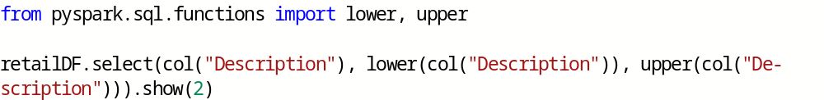
instr():
Checks for the string in a column value.
Example:
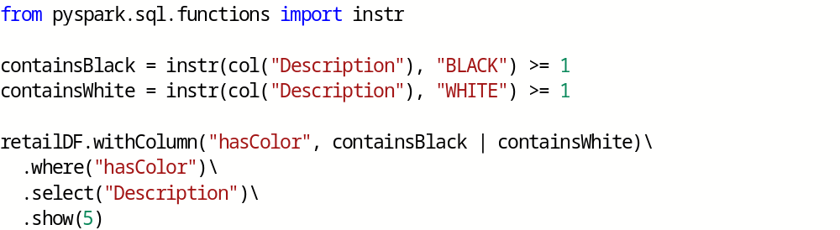
translate():
To replace given characters with other characters.
Example:
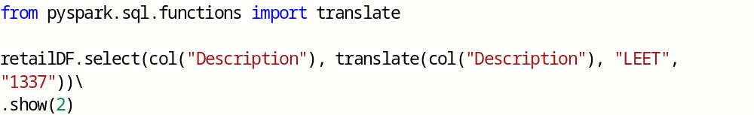
Removing/Appending the spaces in string:
trim(), ltrim() and rtrim() functions removes the spaces from column values.
lpad() and rpad() appends the spaces to column values.
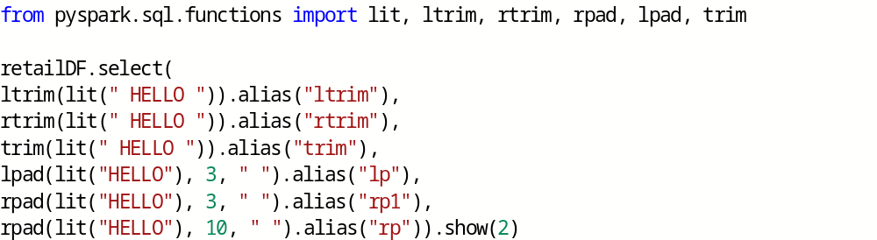
Note that if lpad or rpad takes a number less than the length of the string, it will always remove values from the right side of the string.

Regular Expressions:
Regular expressions gives the user an ability to specify a set of rules to use to either extract values from a string or replace them with some other values.
There are two key functions in Spark that you’ll need in order to perform regular expression tasks: regexp_extract and regexp_replace. These functions extract values and replace values, respectively.
regexp_replace():
To replace string using regular expression.
Example:
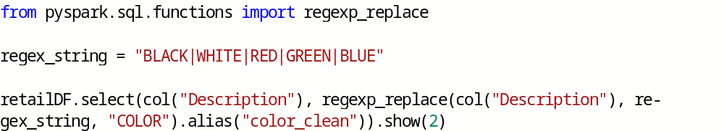
regexp_extract():
To extract a specific string using regular expression.
Example:
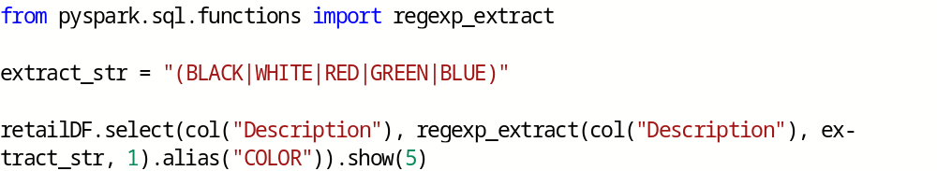
Dealing with dynamic arguments:
Followin is the way to deal with variable number of arguments,
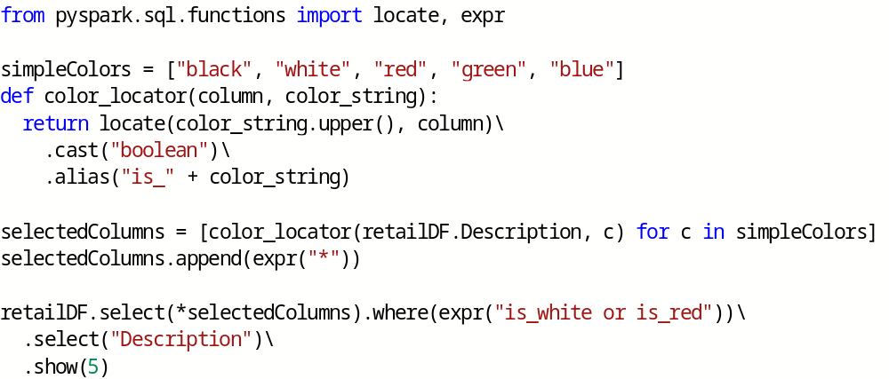
Working with Nulls in Data:
There are two things you can do with null values:
you can explicitly drop nulls (or)
you can fill them with a value

Coalesce:
If first column argument value is not NULL, then picks the first column argument otherwise picks second column argument.
Example:

ifnull, nullIf, nvl, and nvl2:
There are several other SQL functions that you can use to achieve similar things.
Example:
ifnull - allows you to select the second value if the first is null, and defaults to the first.
nullif - returns null if the two values are equal or else returns the second if they are not.
nvl - returns the second value if the first is null, but defaults to the first.
nvl2 - returns the second value if the first is not null; otherwise, it will return the last specified value
Example:
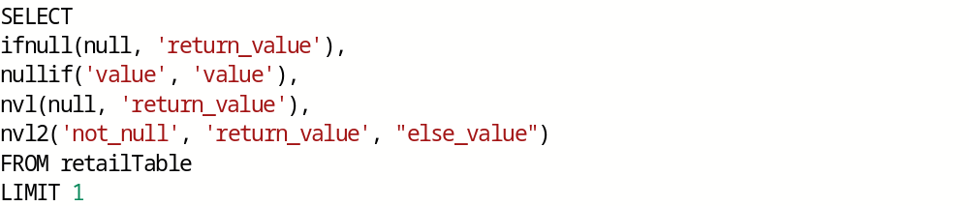

drop:
Removes rows that contain nulls.
Default is to drop any row in which any value is null:
Example:
Using “all” drops the row only if all values are null or NaN for that row
Example:

We can also apply this to certain sets of columns by passing in an array of columns
Example:
fill:
To fill null values in one or more columns with a set of values.
Example:
We can also do this with a dictionary,
Example:
replace:
By using replace() function, one can also replace other than null values.
Example:
